|  |  |
| --- | --- |
| République de Côte d’ivoire |  |
| |  | | --- | | **Université Felix Houphouët Boigny de Cocody** |     **Ministère de l’Enseignement Supérieur et de la Recherche Scientifique** | |
|  | |

|  |
| --- |
| Union-Discipline-Travail |







*ENGLISH LICENCE 3 PROJECT*

STUDENT :

KOUASSI Yves Anselme Magloire

PROFESSOR:

M.DEMBELE

COMPUTER HADWARE DEVICES

COMPUTER HARDWARE DEVICE

DESKTOP COMPUTER DEVICES

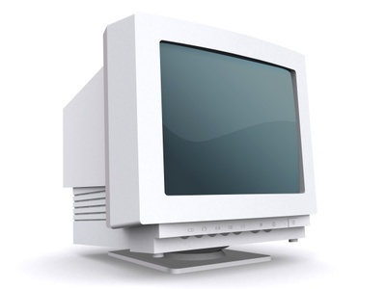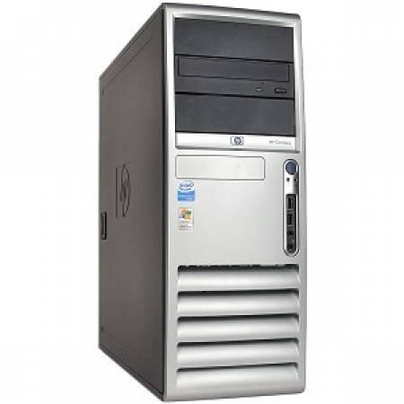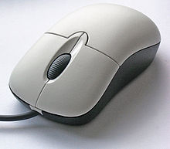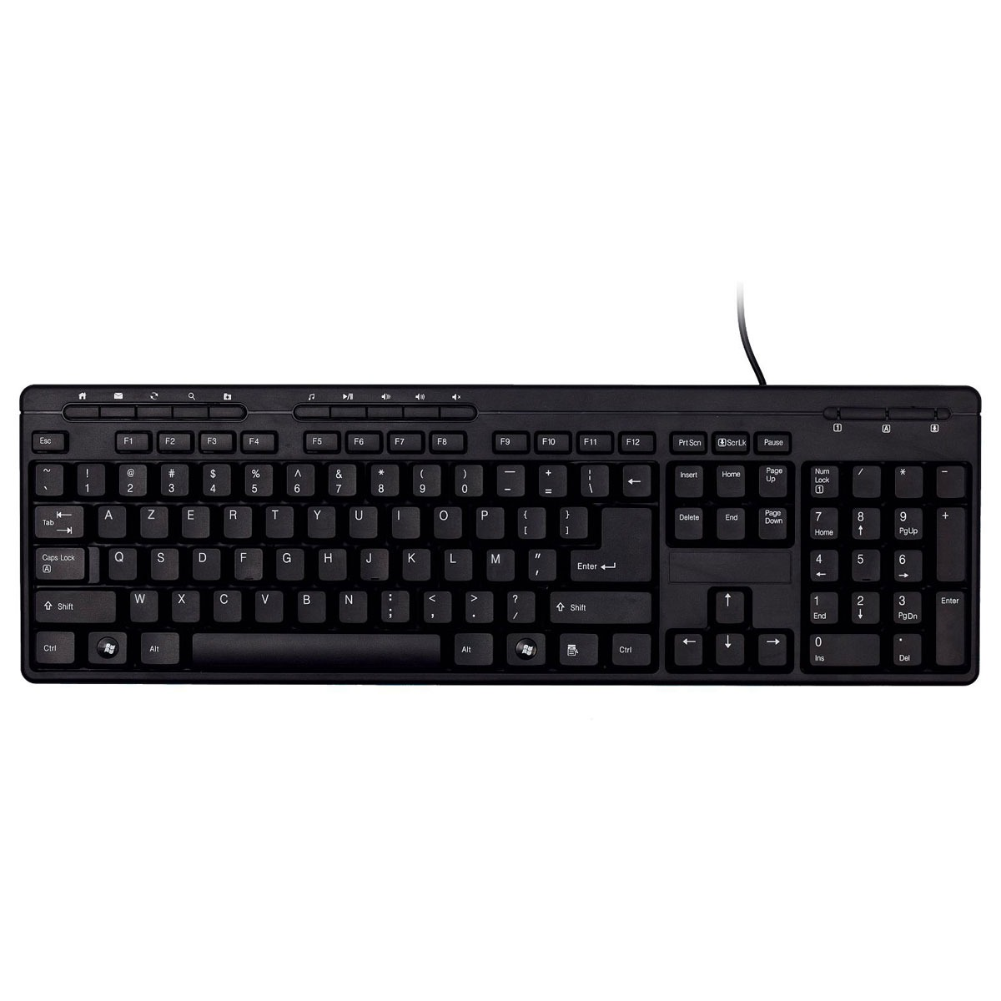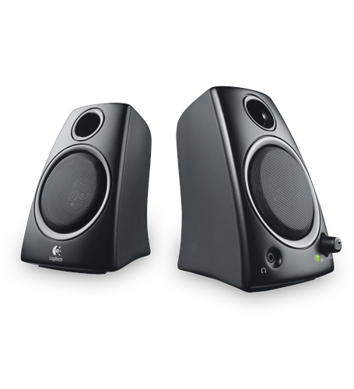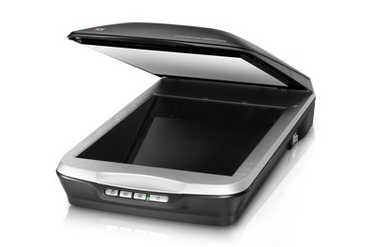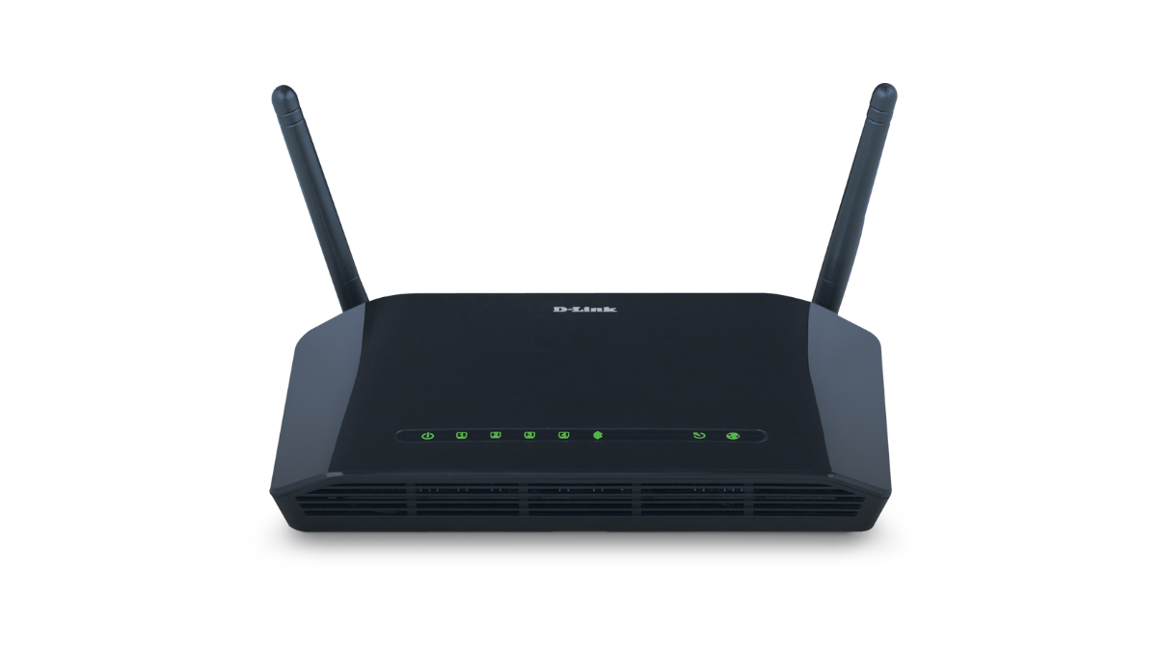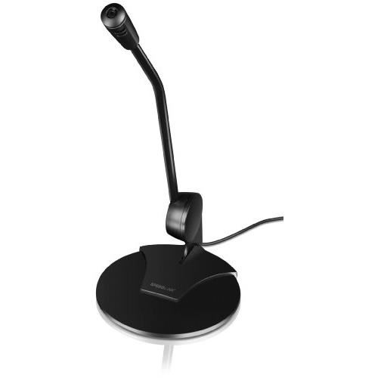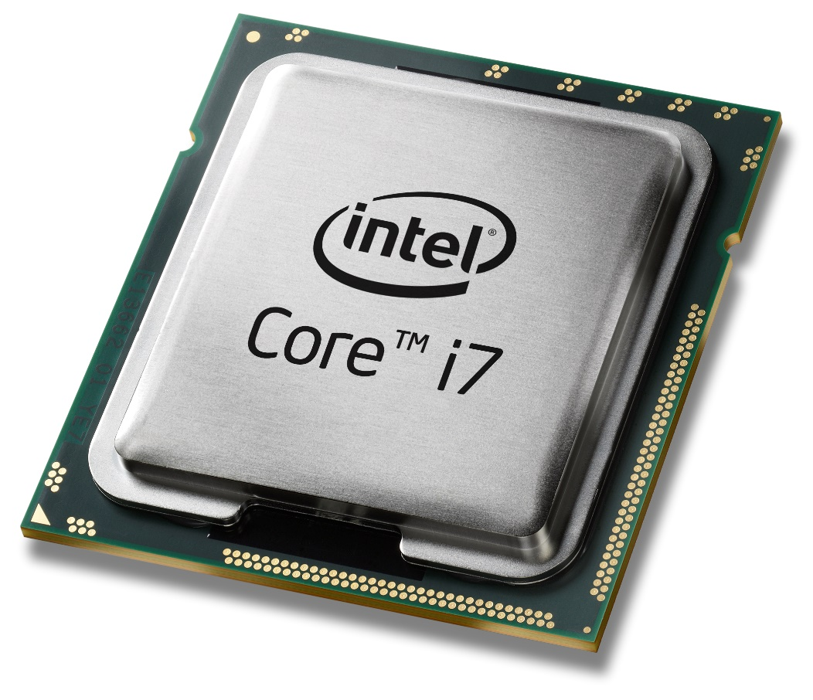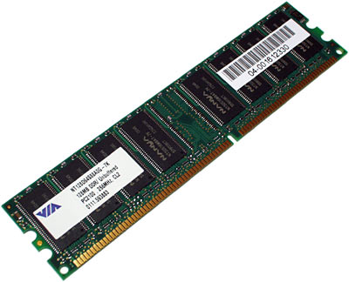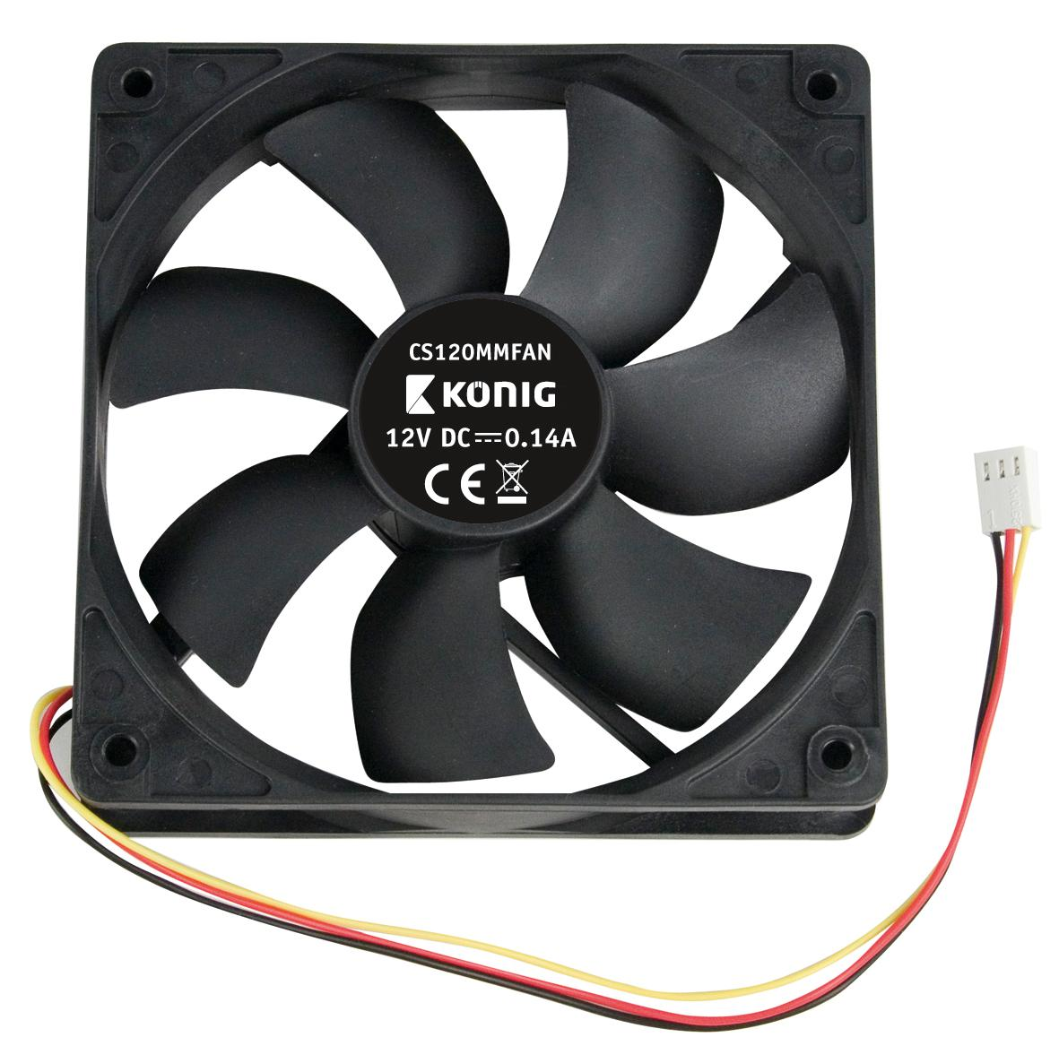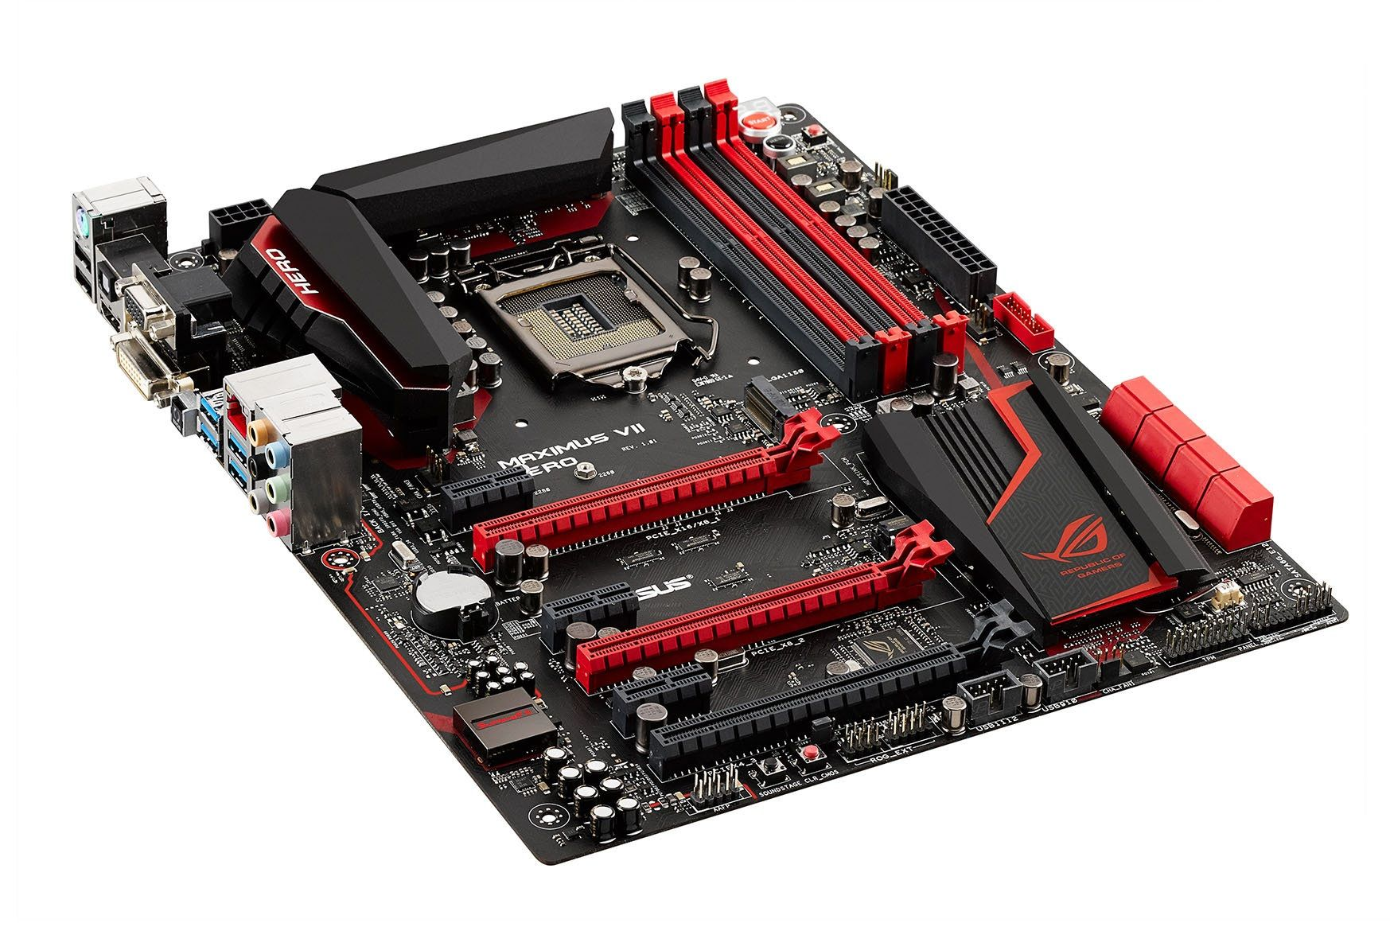

/ˈsentrəl ˈprəʊsesɪŋ ˈjuːnɪt/

Central Processing Unit (CPU)

/ˈmɒnɪtə(r)/

Monitor

## keyboard

/ˈkiːbɔːd/

/ˈspiːkəz/

Speakers

/maʊs/

Mouse

Modem

/ˈskænə(r)/

Scanner

/ˈməʊdem/

/ˈmaɪkrəfəʊn/

Microphone

Processor

/ˈprəʊsesə(r)/

/ˈrændəm ˈækses ˈmeməri/

Random Access Memory

/ˈkuːlɪŋ fæn/

cooling fan

/ˈmʌðəbɔːd/

## Motherboard

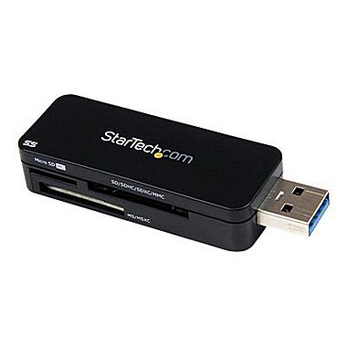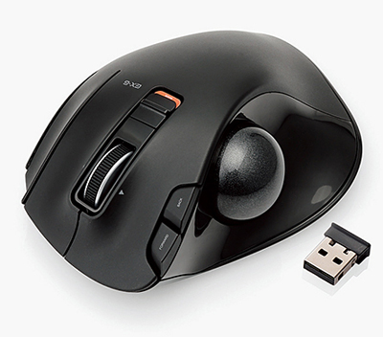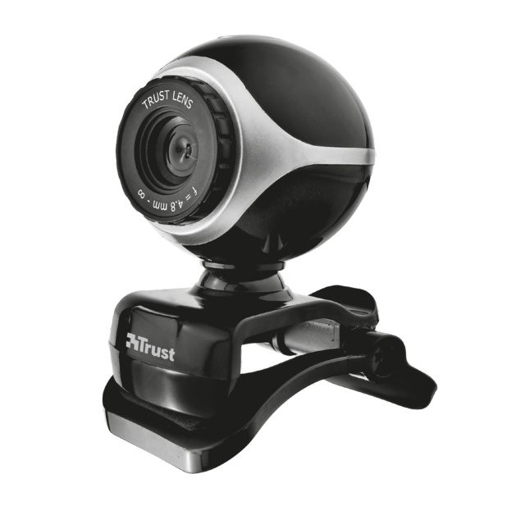

/ˌjuːnɪˈvɜːsl sɪərɪəl bʌs (USB) (juː-ɛs-bi)ː meməri kɑːd əˈdæptə(r)/

Universal Serial Bus (USB) memory card adapter

/ˈwebkæm/

webcam

/ˈwaɪələs trækbɔːl [maʊs](http://lingorado.com/ipa/)/

Wireless Trackball Mouse

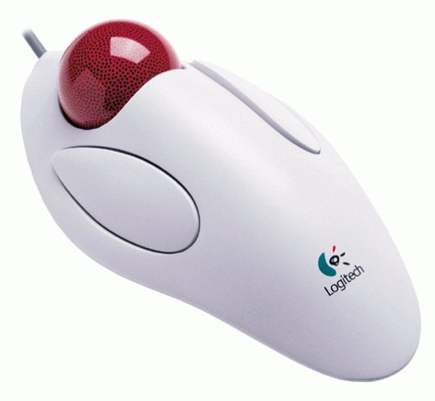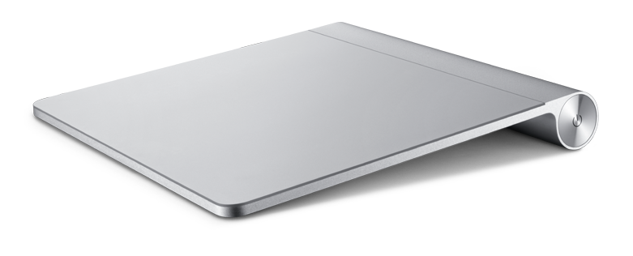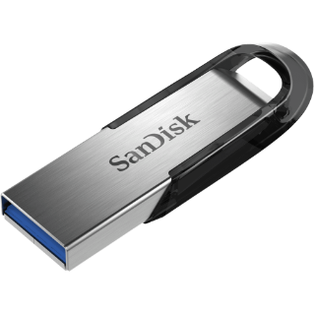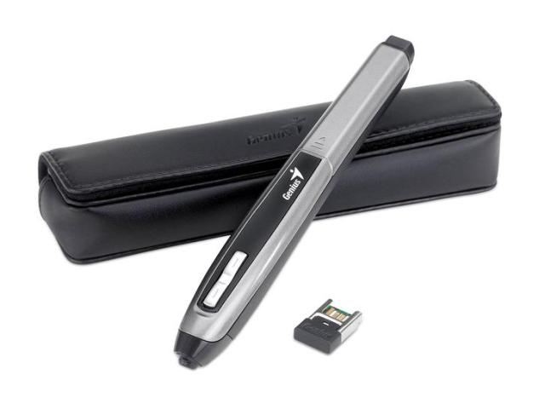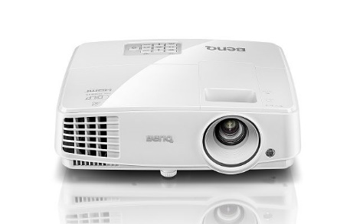

/ˈtrækbɔːl maʊs/

/ˈtrækpæd/

/prəˈdʒektə(r)/

/pɛn ˈɪnpʊt /

/pɛn draɪv/

trackball mouse

trackpad (for MAC)

Projector

Pen Input

Pen drive

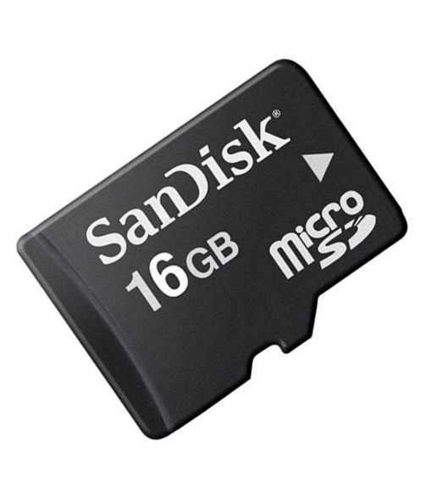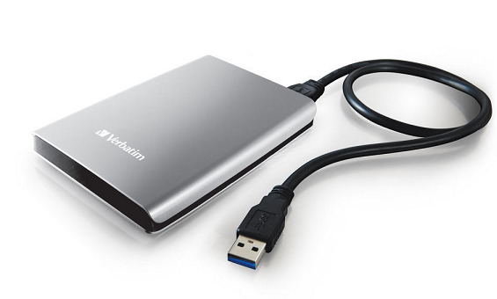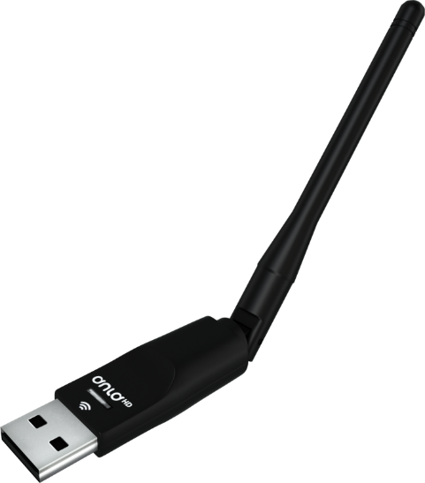

/ˈwaɪələs /fɪˈdeləti (ˈwaɪ faɪ)

ˈwaɪələs əˈdæptə(r)/

**Wireless Fidelity** (Wifi)

Wireless adaptor

/ɪkˈstɜːnl hɑːd draɪv/

External hard drive

/ˈmeməri kɑːd/

memory card

printer

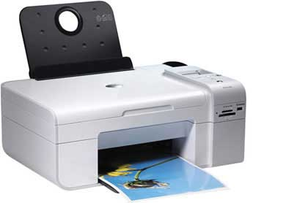

/ˈprɪntə(r)/

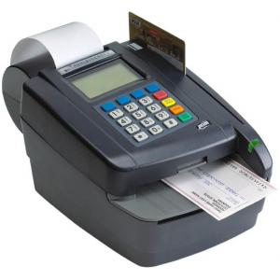

Magnetic Ink Card Reader(micr)

/mæɡˈnetɪk ɪŋk kɑːd ˈriːdə(r)/

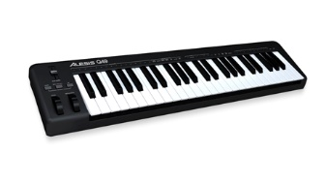

/ˈmɪdi ˈkiːbɔːd/

MIDI keyboard

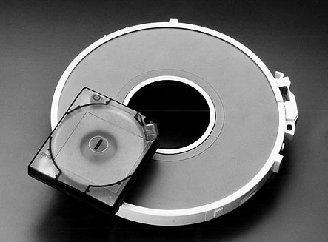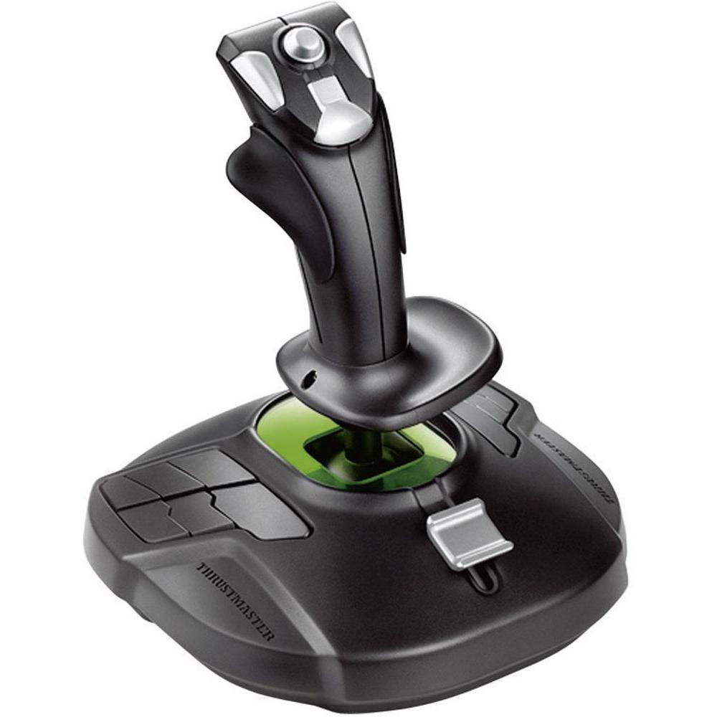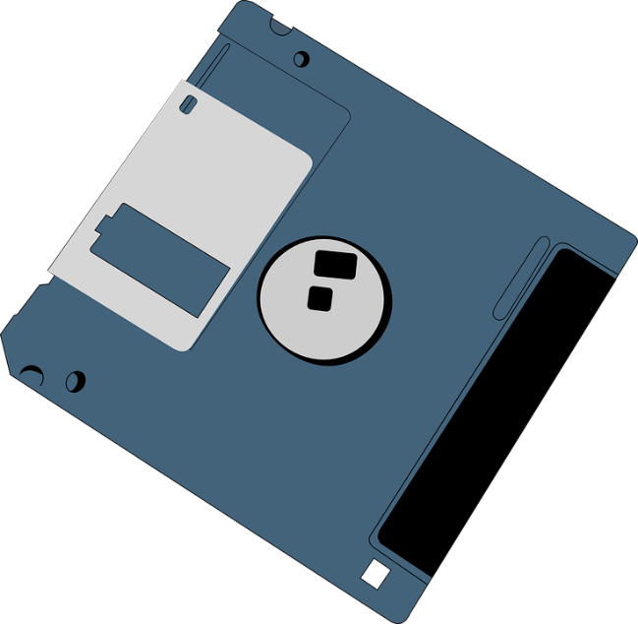

/ˈflɒpi dɪsk/

Floppy disk

/mæɡˈnetɪk teɪp draɪv/

Magnetic Tape Drive

/ˈdʒɔɪstɪk/

Joystick

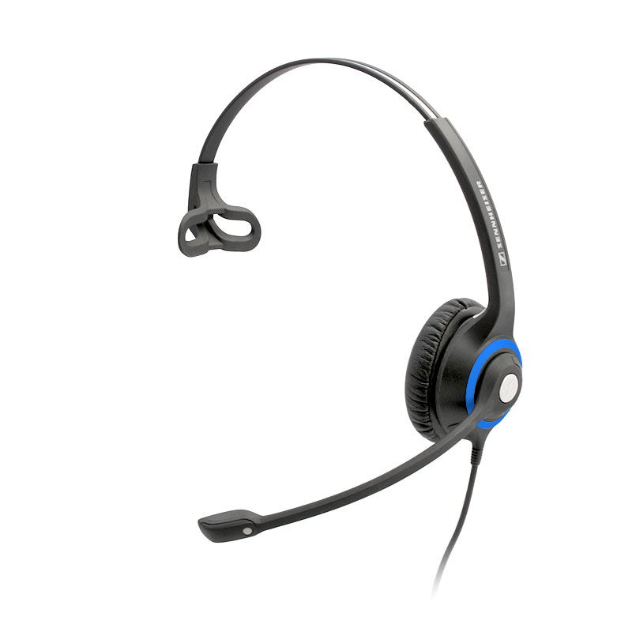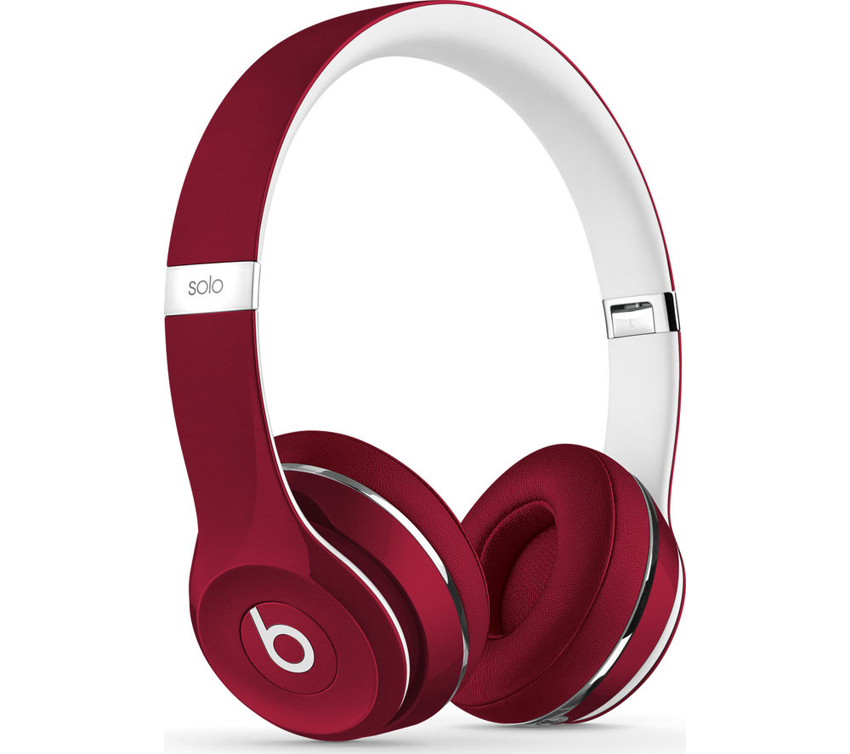

/ˈhedfəʊnz/

HeadPhones

/ˈhedset/

Headsets

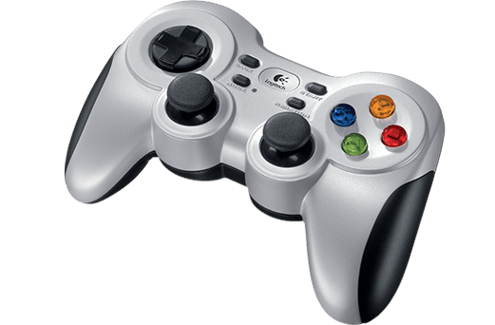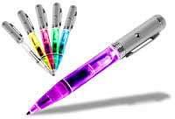

/ˈɡeɪmpæd/

gamepad

/laɪt pen/

Light pen

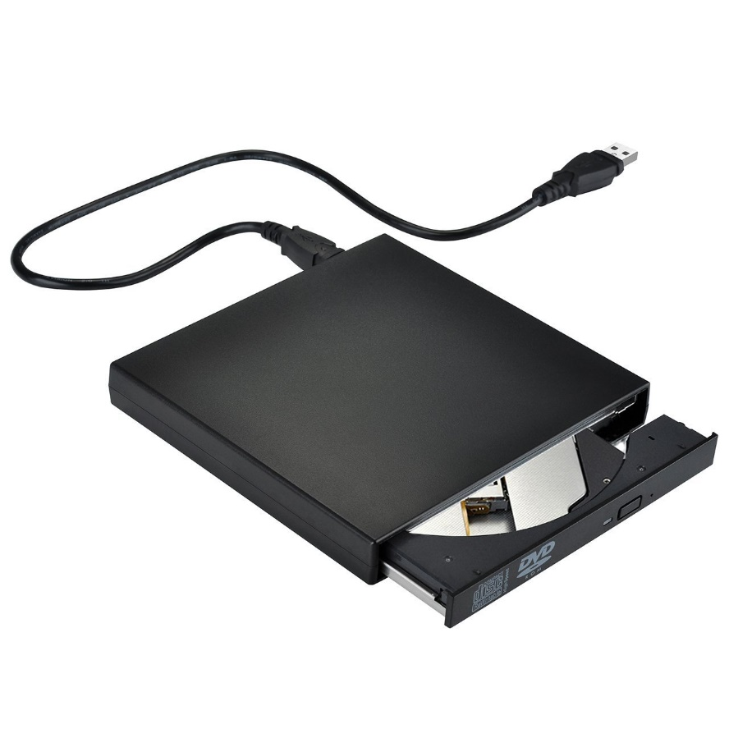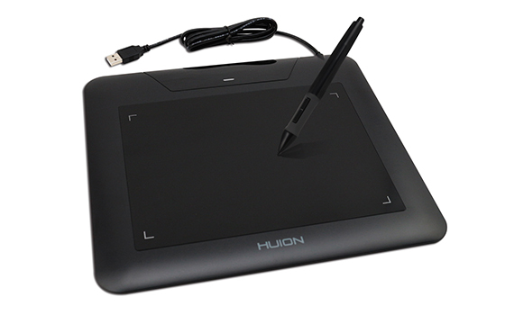

Graphic tablet

/ɪkˈstɜːnl ˈɒptɪkl draɪv/

External optical drive

/ˈɡræfɪk ˈtæblət/

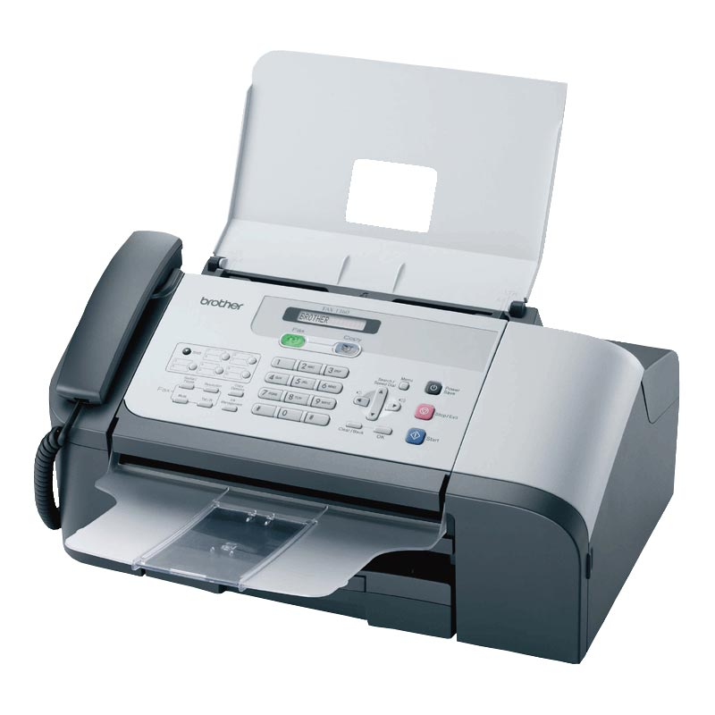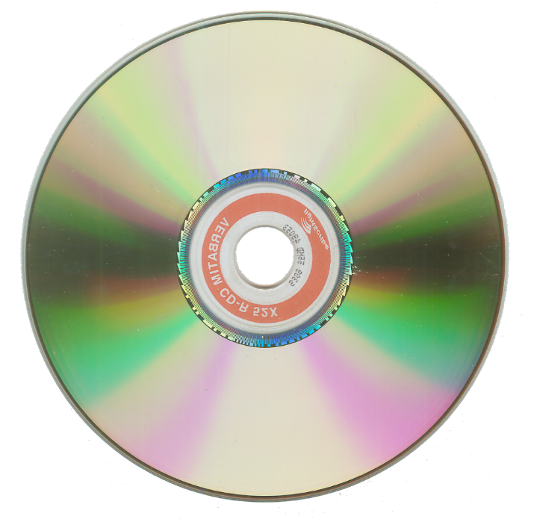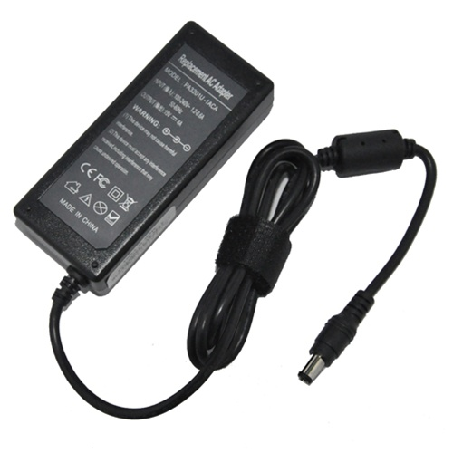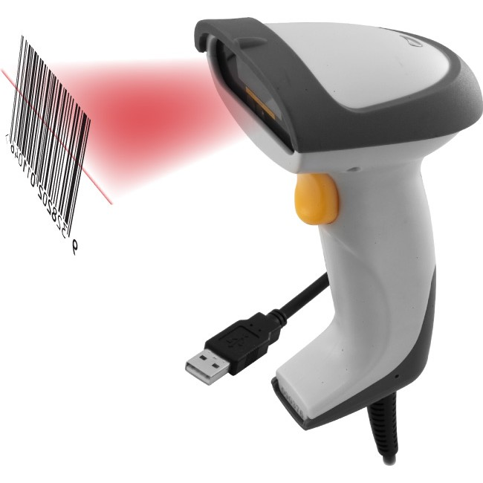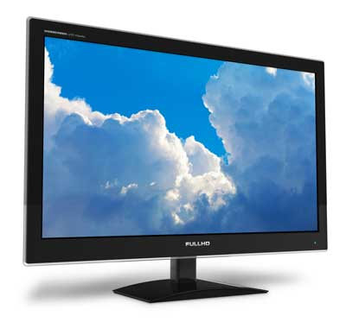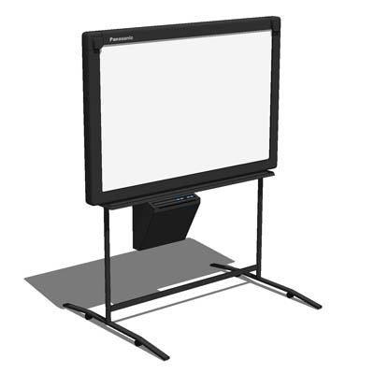

/kəmˈpækt dɪsk/

/ˌeɪ ˈsiː əˈdæptə(r)/

/fækˈsɪməli/

Facsimile

Compact disc

AC ADAPTER

/bɑː(r) kəʊd ˈriːdə(r)/

Bar Code Readers

/ɪˌlekˈtrɒnɪk ˈwaɪtbɔːd/

Electronic Whiteboard

/flæt ˈmɒnɪtə(r)

Flat monitor

Flat monitor

PARTS OF A LAPTOP

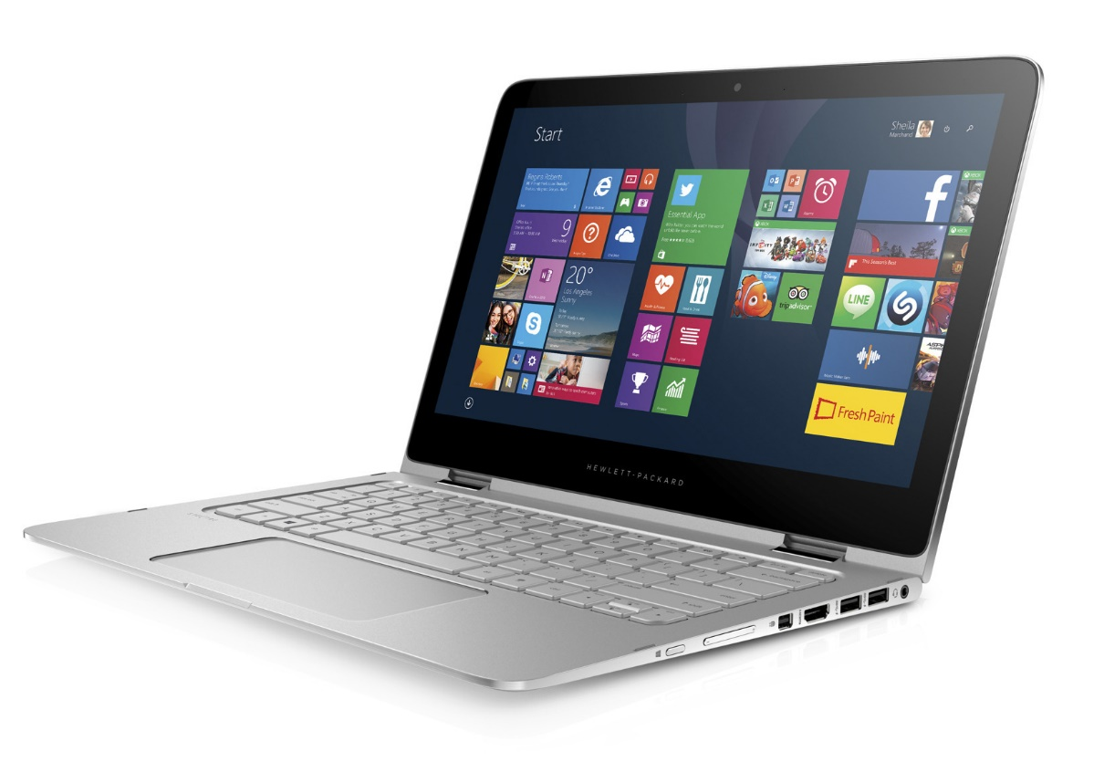

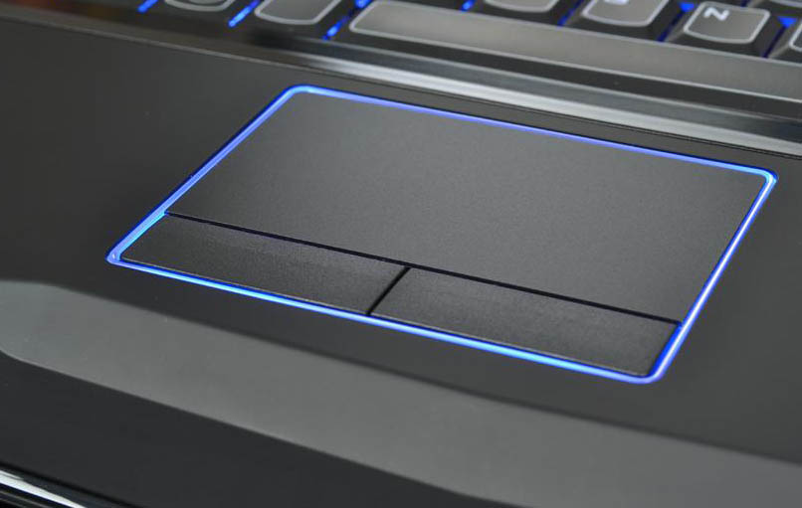

/'tʌtʃ 'pæd/

TOUCHPAD

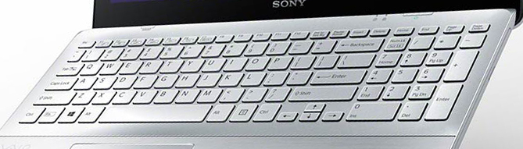

/ˈkiːbɔːd/

Keyboard

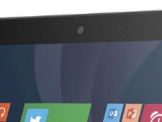

/ˈwebkæm/

Webcam

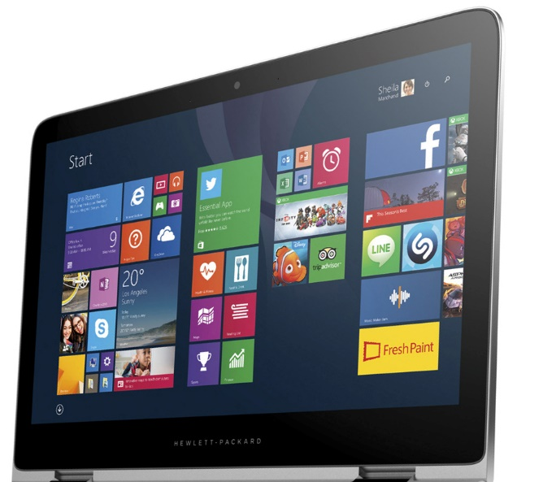

/ˈskri:n/

Screen

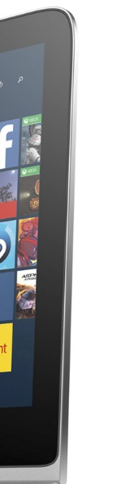

Bezel

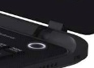

POWERBUTTON

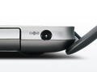

DIRECT CURRENT (DC) IN JACK

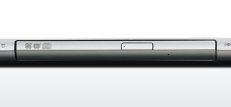

OPTICAL DRIVE

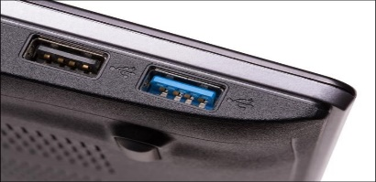

USB PORT

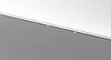

LED INDICATORS



BUILT-IN MICROPHONE

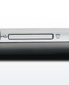

CARD READER



ETHERNET LAN PORT

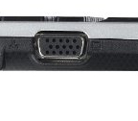

External Display (VGA) port

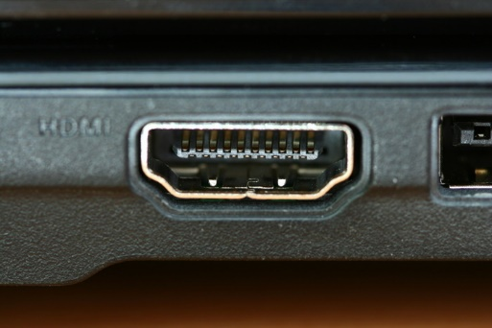

HDMI PORT

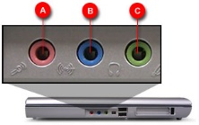

A-MICROPHONE JACK

B- AUDIO OUT JACK

C- LINE IN JACK

REAR PANEL

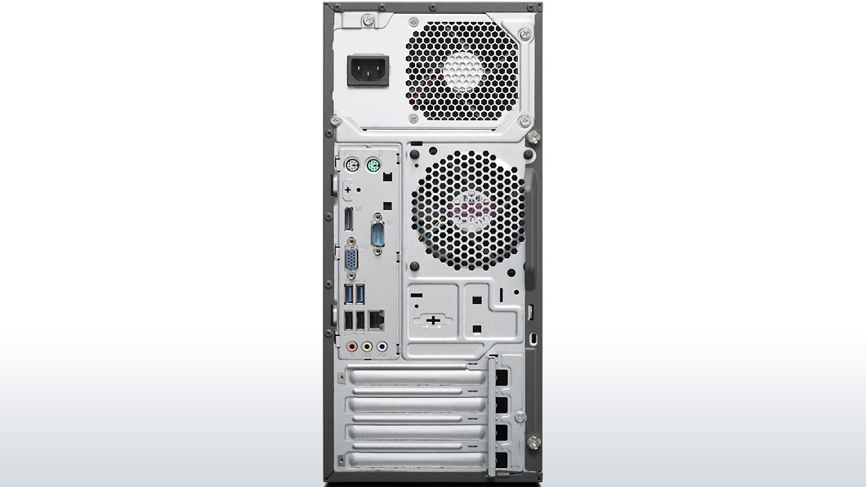

4

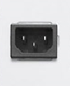

Power Connector

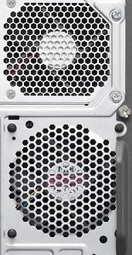

Case Cooling Fan

Fan

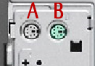

A-Keyboard Connector

B-Mouse connector



HDMI port



Serial Com Port



VGA port



A-USB (3.0) PORTS

B- USB (2.0) PORTS



Ethernet Lan Port

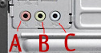

**A-** Microphone Jack

**B-** Audio Out Jack

**C-** Line In Jack

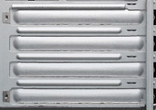

Expansion Slots

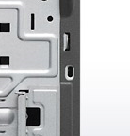

Security Lock Port

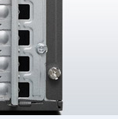

Thumb screw

ACTIONS VERBS OF DEVICES

|  |  |  |  |
| --- | --- | --- | --- |
| **Devices** | **Verbs** | **Preterit** | **past participle** |
| PRINTER | To print | Pinted | printed |
| MONITOR | To display | Displayed | displayed |
| MICROPHONE | To speak | Spocke | spoken |
| SCANNER | To scanner | scanned | scanned |
| DISK DRIVE | To read | Read | read |
| MOUSE | To click | clicked | clicked |
| KEYBOARD | To type | typed | typed |
| MODEM | To connect | connected | connected |
| POWER BOUTON | To turn on/off  To switch on/off | Turned on/off | Turned on/off |
| SPEAKERS | To amplify | amplifed | amplifed |
| HEADSET | To talk | talked | talked |
| UNDULATOR | To provid | provided | provided |
| FLOPPY DISK | To read | read | read |
| WEBCAM | To transmet | transmeted | transmeted |
| DRONE | to carry | carred | carred |
| DIGITZRER | To hand-draw | Hand-drew | Hand-drawn |
| TRACKBALL | To move | moved | moved |
| 3D PRINTER | To print | printed | printed |
| VIDEO PROJECTOR | To project | projected | projected |
| SCREEN PROTECTOR | To protect | protected | protected |
| USB HUB | To save | saved | saved |
| MIDI KEYBOARD | To type | typed | typed |
| FILM RECORDER | To recorde | recorded | recorded |
| MAGNETIC INK CHARACTER READER | To read | read | read |
| LAPTOP BATTERY | To store | stored | stored |
| POTTER | To print | printed | printed |
| FAX | To fax | faxed | faxed |
| MICROFICHE | To stock | stocked | stocked |
| ELECTRONIC WIHTEBOAD | To display | displayed | displayed |
| OMNICHARGE |  |  |  |
| VIDEO CAPTURE | To capture | captured | captured |
| JOYStICK | To play | played | played |
| MAGNETIC TAPE DRIVE | To read | read | read |
| GRAPHSICS TABLET | To hand-draw | Hand-drew | Hand-drawn |
| HARD DISK DRIVE | To save | saved | saved |
| (RAM)RANDOM ACCESS MEMORY | To run | run | run |
| PROCESSOR SOCKET | To execut | executed | executed |
| AC/DC ADAPTER | To convert | converted | converted |
| VIDEO CARD | To process | processed | processed |
| NETWORK CARD | To connect | connected | connected |
| MOTHER BOARD | To connect | connected | connected |
| AUDIO CARD | To convert | converted | converted |
| PEN INPUT | Ton write | wrote | written |
| BARCODE READER | To scanned | scanned | Scanned |
| HEADPHONES | TO listen | Listened | Listened |